Vindor Assembly

# Overview

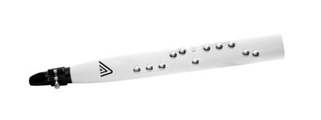

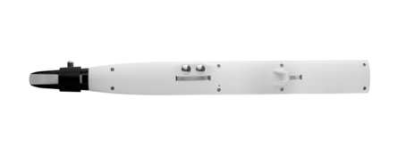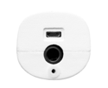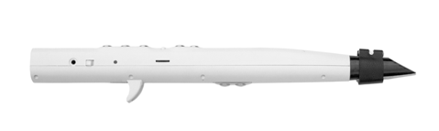





# Bottom

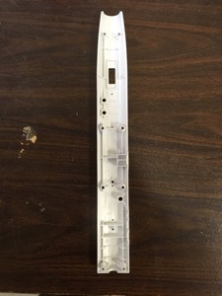

Place thick grounding wires into holes from the bottom. Long side of the wire goes toward the front.

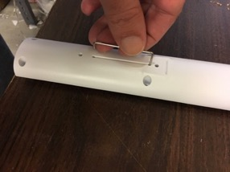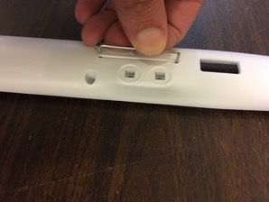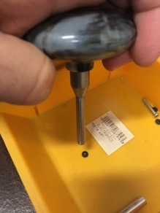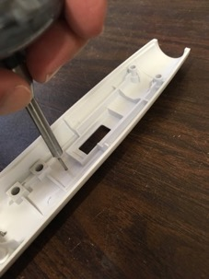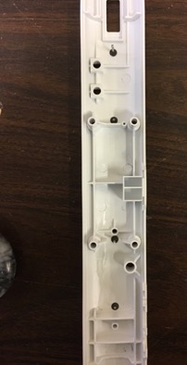

Find the small “Octave” PCB and attach LCD/OLED display.

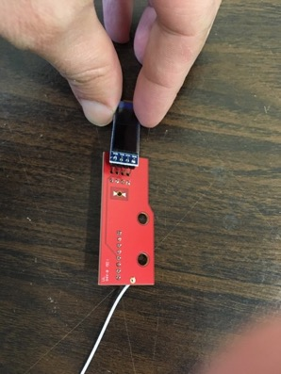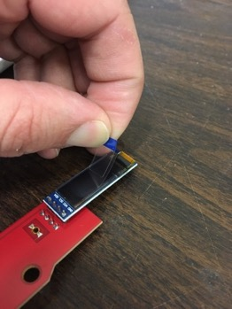

Insert into bottom shell making sure that LCD fills hole completely.

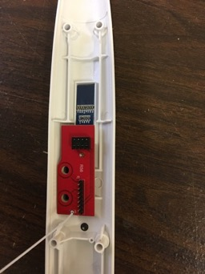

Attach cylinder on white wire to the thick grounding wire near the thumb hook.

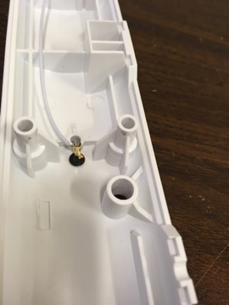

Place the thumb hook and screw in with ½” screw.

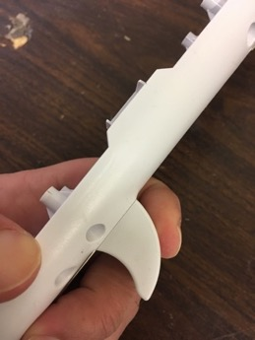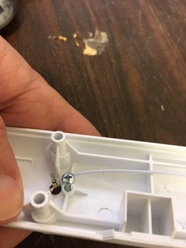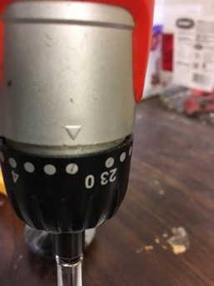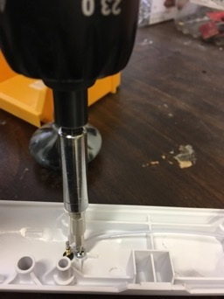

Attach tubes to the mouthpiece holder. Middle tube is smaller than outer tube. Then attach other end of the bigger tube to the hole near the far side of the bottom shell.

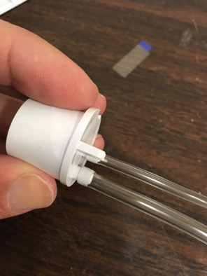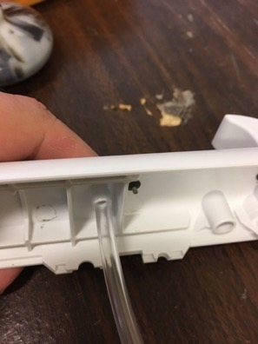

Place two carriage bolts. Then screw nuts from the opposite side using torque 4. Use locktite.

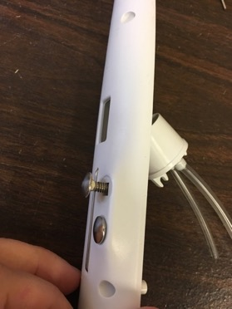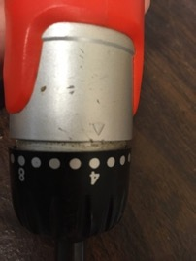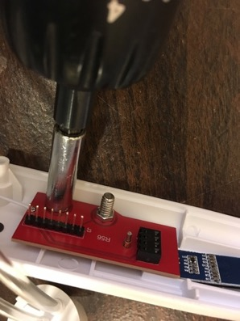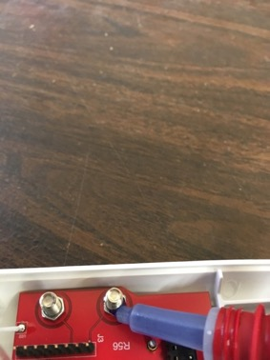

Use hot glue to permanently attach LCD/OLED to the shell. This prevents users from pushing the LCD into the shell.

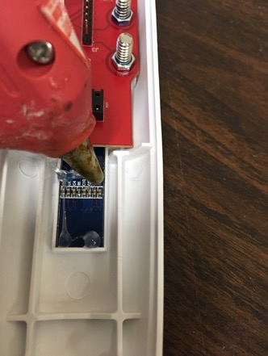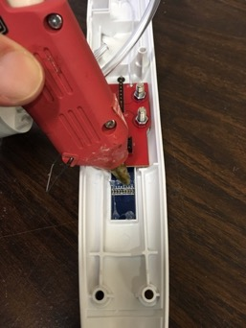

# PCB prep

Place battery into PCB with plus side forward (see silkscreen on PCB) and ensure power switch is on by flipping it in the direction of the battery.

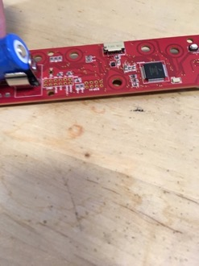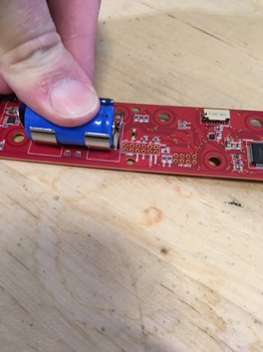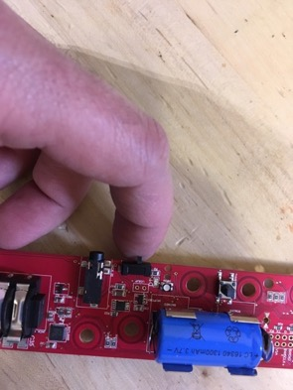

Flash the firmware. I use Segger J-Link.

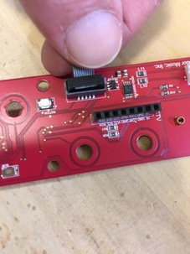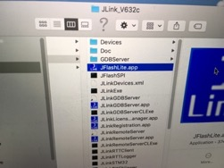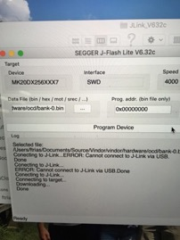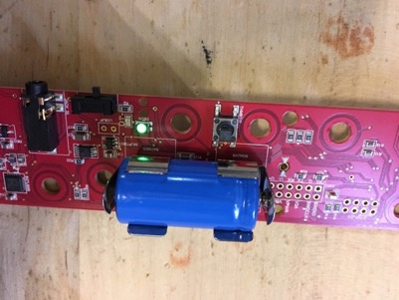

On the bottom side of the PCB, insert the button cap.

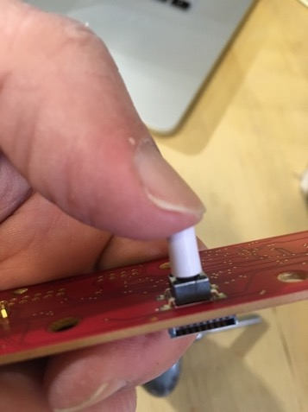

Near the battery, insert the light pipe. Then place the switch cap on the power switch.

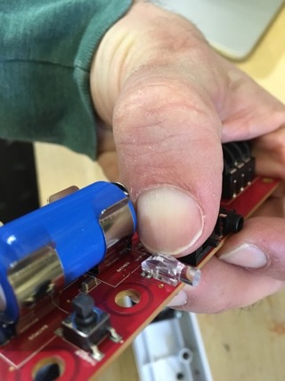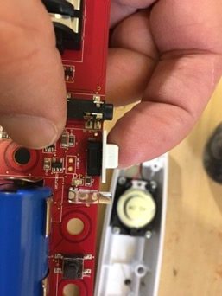

# Top

Place the speaker foam near the top. Make sure it is oriented correctly. Place the speaker and screw in ¼” screws (4 of them) using torque 0.

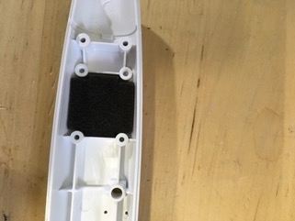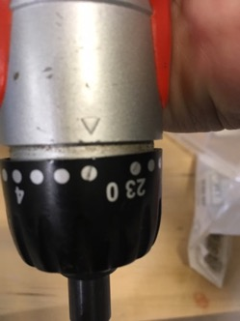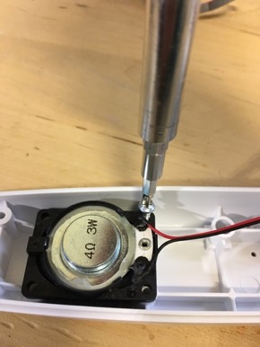

Optional. Place plastic washer on 4th hole and put in carriage screw.

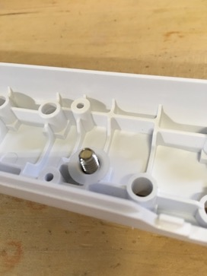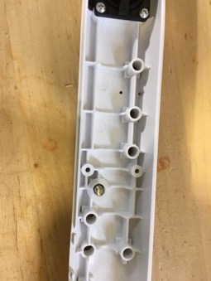

Attach bent wire into holes between first two bolt holes. Longer side goes on the inside, and shorter side on the outside. Use pressing tool to attach compression nut to the longer side of shell.

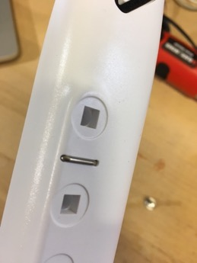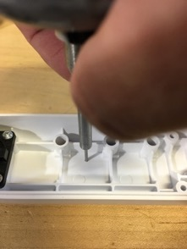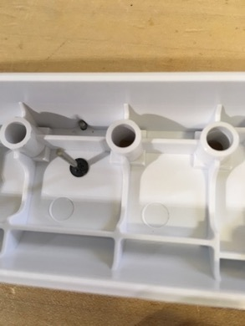

# Put it all together

Place the PCB into the top shell making sure the bent wire goes into the cylinder compression piece.

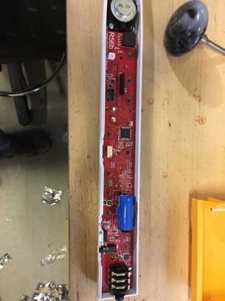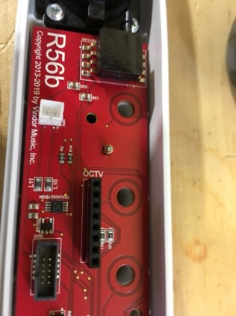

Optional. Screw in any bolts you optionally placed for support.

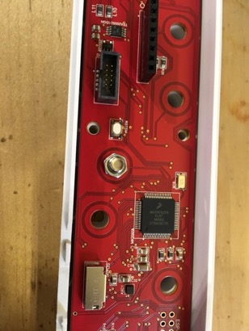

Carefully flip the top shell over and place all the carriage bolts into the proper holes.

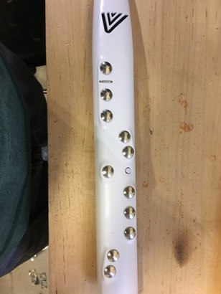

Place a piece of cardboard or other hard part on top of the shell and flip it over. The cardboard prevents the bolts from falling off.

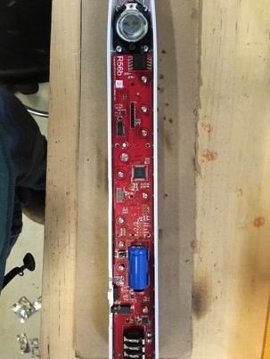

Using a placement tool, put on all the nuts on the bolts.

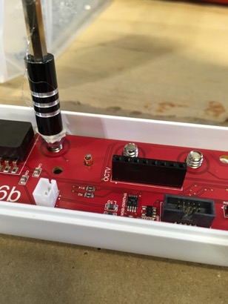

Using torque 4, screw down the nuts.

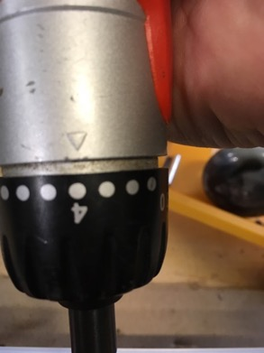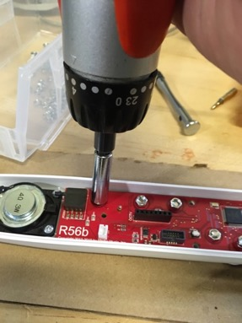

Use loctite on nuts.

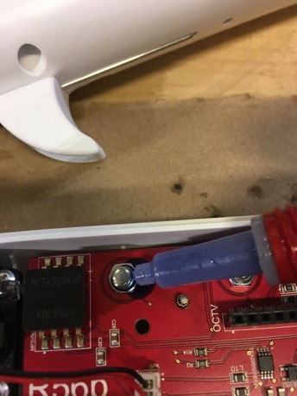

Attach the speaker wire.

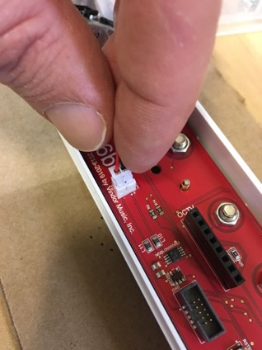

Attach the small tube the air pressure sensor.

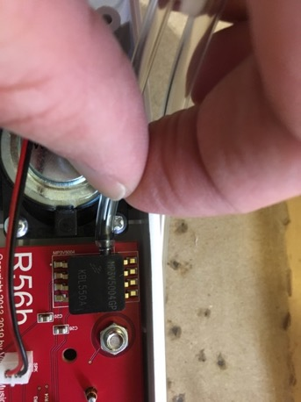

Place the mouthpiece holder in its place making sure to line up guide groove.

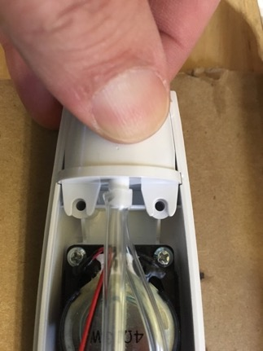

The top and bottom are ready for assembly.

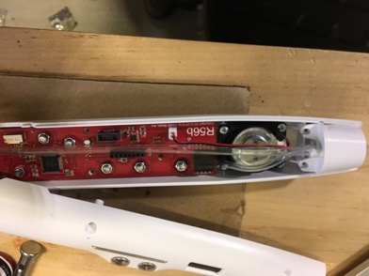

Carefully guide tube between button and battery by pushing it into place.

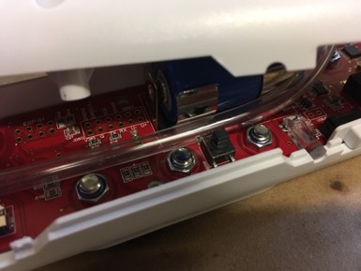

Place the long cap on the button.

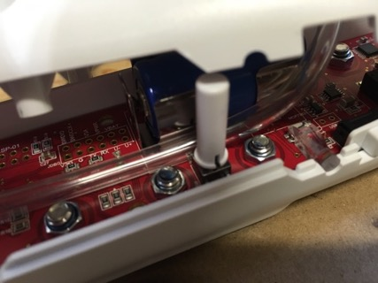

Join the top and bottom. Make sure the cap you just placed goes through the hole. Also make sure that the header pins on the front of the “Octave” PCB line up with the mating header on the main PCB.

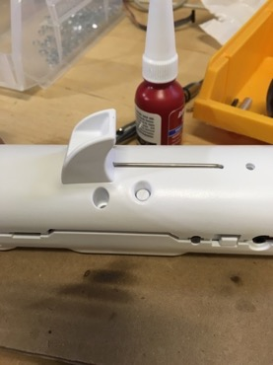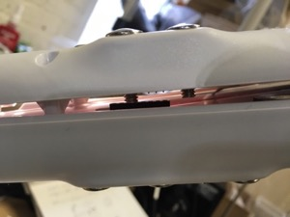

Using torque 1, screw in ¾” screws (6 of them) on the bottom shell.

